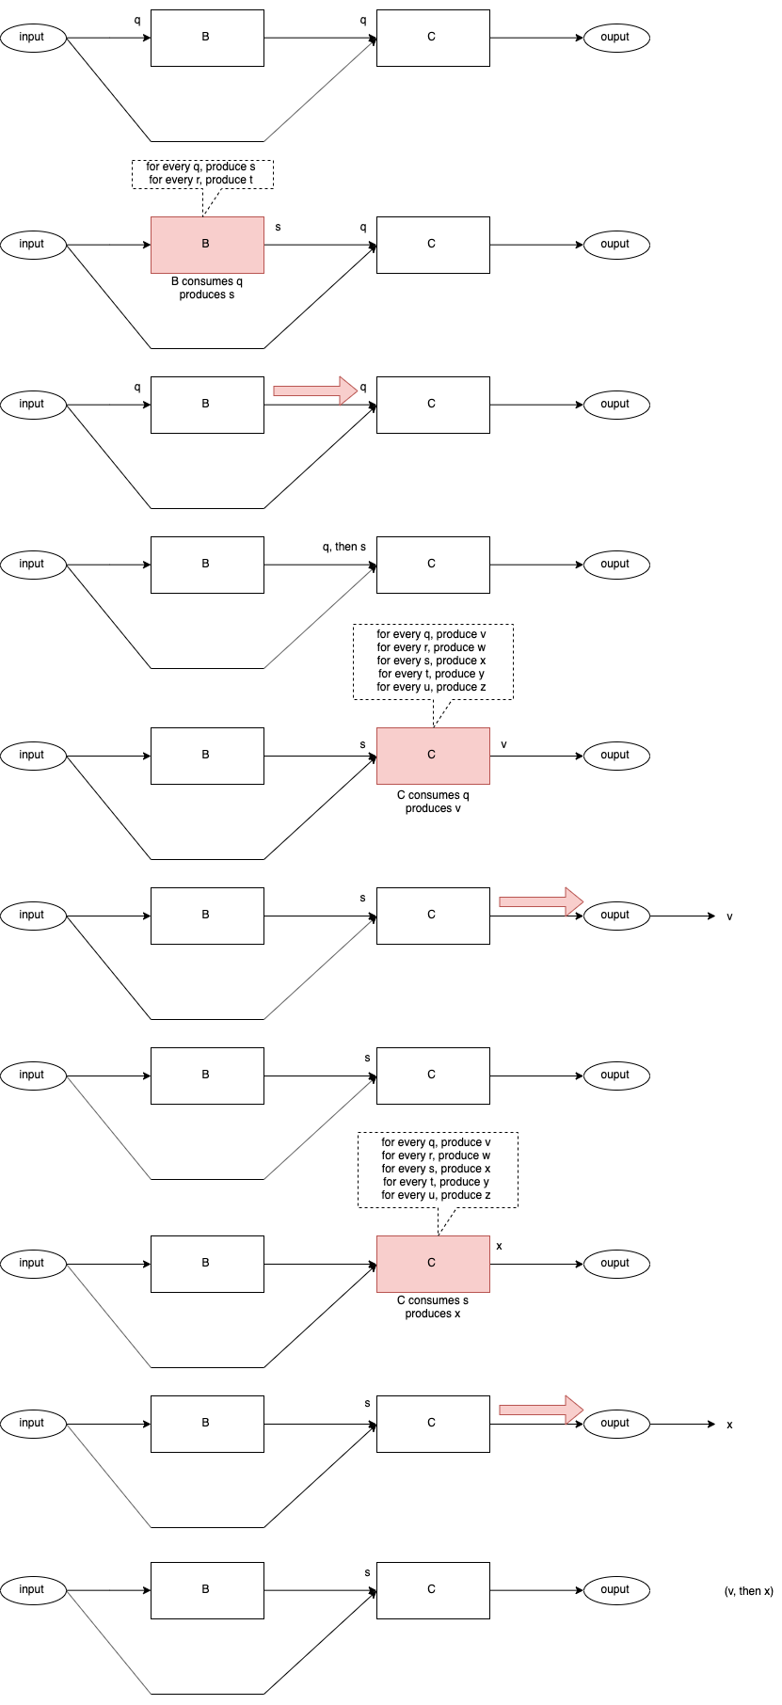
Fig. <$n:figure:AsyncControlFlowBC> Control Flow BC

